Recipe Finder website

G Anitha 421105
K Rishitha 421174
Introduction:
Recipe Finder is a web application designed to help users discover, save, and share recipes. With an intuitive interface and robust features, Recipe Finder aims to provide users with a seamless experience in exploring and managing their favourite recipes.
Key Features:
1. Recipe Database: Recipe Finder boasts a comprehensive database of recipes spanning various cuisines, meal types, and dietary preferences.
2. User Authentication: Users can create accounts, log in, and securely manage their profiles. Authentication ensures data security and personalization.
3. Recipe Search: Users can search for recipes based on keywords, ingredients, categories, and more. Advanced search filters enable precise recipe discovery.
4. Recipe Details: Each recipe includes detailed information such as ingredients, preparation instructions, cooking time, servings, and nutritional facts.
5. User Interaction:
- Comments: Users can engage with recipes by leaving comments, sharing tips, and asking questions.
- Favourites: Users can mark recipes as favourites for quick access and future reference.
- Rating: Users can rate recipes based on their experience, providing valuable feedback to the community.
- History: Users can view their recipe browsing history to revisit previously viewed recipes.
6. User-generated Content:
- Recipe Collections: Users can create personalized recipe collections to organize and categorize their favorite recipes.
- Notes: Users can create and attach notes to recipes, enabling personalization and customization.
7. Social Features:
- Sharing: Users can share recipes via social media platforms, email, or direct links, extending the reach of the application.
- Following: Users can follow other users to stay updated on their activity, such as recipe uploads, comments, and collections.
Technology Stack:
- Frontend: HTML, CSS, JavaScript, React.js (or other frontend frameworks)
- Back end: Node.js, Express.js, MongoDB (or other databases)
- Authentication: JSON Web Tokens (JWT)
- API Integration: External APIs for recipe data (optional)
- Deployment: Cloud hosting platforms like AWS, Heroku, or Vercel
Future Enhancements:
1. Recommendation Engine: Implement machine learning algorithms to provide personalized recipe recommendations based on user preferences and browsing history.
2. Recipe Sharing Community: Foster a vibrant community by facilitating user interactions, recipe sharing, and collaborative cooking experiences.
3. Enhanced User Profiles: Expand user profiles to include additional features such as user-generated content statistics, badges, and achievements.
4. Mobile Application: Develop a mobile application version of Recipe Finder to cater to users on the go, offering seamless access to recipes anytime, anywhere.
DATABASE SCHEMA (ER Diagram):

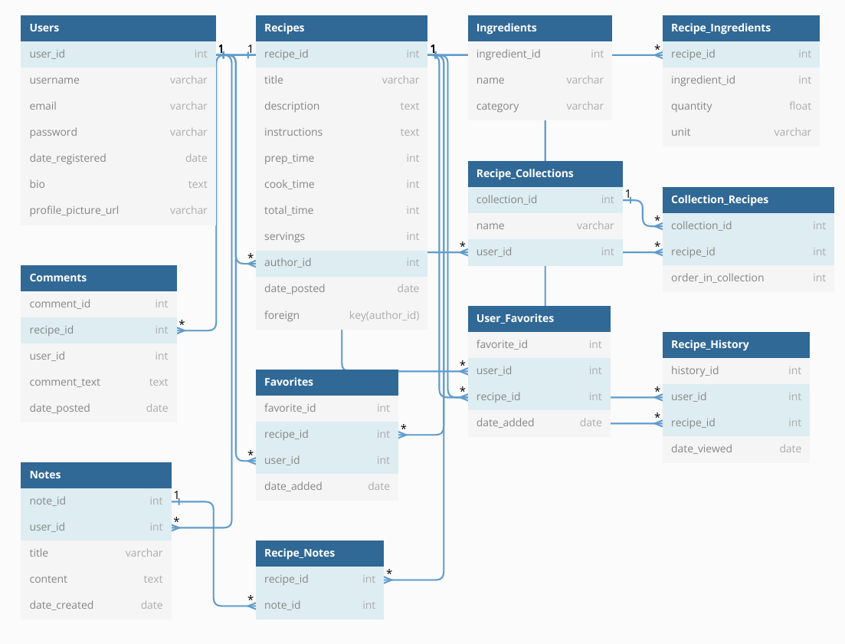
Conclusion:
Recipe Finder aims to revolutionize the way users discover, save, and share recipes online. With its user-friendly interface, extensive feature set, and commitment to continuous improvement, Recipe Finder is poised to become a go-to destination for food enthusiasts worldwide.

